Software Requirements Specification

Clothing Store

Management System

Version 1.0 approved

Prepared by

Aadesh Ingle(17u354)

Ajinkya Chikhale(17u224)

Ashish Gole(17u688)

Ayush Bansal(17u112)

VIIT, Pune

3 October,2018

**1**

Table of Contents

1. Introduction 2

1.1 Purpose 2

1.2 Document Conventions 2

1.3 Intended Audience and Reading Suggestions 3

1.4 Product Scope 3

1.5 References 3

2. Overall Description 3

2.1 Product Perspective 3

2.2 Product Functions 4

2.3 User Classes and Characterstics...........................................................................................................5

2.4 Operating Environment.........................................................................................................................6

2.5 Design and Implimentation contraints..................................................................................................6

2.6 User Documentation..............................................................................................................................6

2.7 Assumptions and Dependencies............................................................................................................6

**3.External Interface Requirments................................................................................................................7**

3.1 User Interfaces........................................................................................................................................8

3.2 Hardware Interfaces................................................................................................................................

5.5 Business Rules 7

Revision History

|  |  |  |  |
| --- | --- | --- | --- |
| **Name** | **Date** | **Reason For Changes** | **Version** |
|  |  |  |  |
|  |  |  |  |

**2**

# 1. Introduction

## 1.1 Purpose

## *This project titled “Clothing Store Management System " is built from the perspective of both the employees and employer. It aims to provide the facilities of adding items, generating bills etc. to the employees. It also aims to provide facilities like adding items, deleting items, updating items, generating sales report for a specific tenure, generating bills to the employer. This SRS document is written as to help us to verify and validate our project. It also serves as a user manual for the end users.*

## 1.2 Document Conventions

Heading: Font Size: 16

Font Style: Bold

Font: Times New Roman

Sub Heading:

Font Size: 14

Font Style: Bold

Font: Times New Roman

Content:

Font Size: 12

Font: Times New Roman

## 1.3 Intended Audience and Reading Suggestions

The intended audience includes developers, testers, administrators and the users of the system. This SRS document is written as to help us to verify and validate our project. It will be used by testers to check whether the requirements are met. It also serves as a user manual for the end users.

## 1.4 Product Scope

The project intends to ease the efforts of the users of the system by providing them the facilities to generate bills and automatic calculating the final price of the product. It also helps the administrator to generate sales report and calculate the profit for a specific tenure.

## 1.5 References

The documents and websites referred to, are as follows:

1.IEEE templates for SRS

2.Software Engineering by Roger Pressman

# 2. Overall Description

This project provides individual account to each user and the administrator.

## 2.1 Product Perspective

The Clothing Store Management System is a new self-contained product.

The basic idea behind the project is to ease the task of users by allowing them to generate bills and add miscellaneous expenses done.

This project also intends to reduce the effort of the system administrator by allowing them to generate sales reports for the desired period and thus check the net profit of the store. This project also intends to allow the administrator to apply a discount on specific items.

## Product Functions

### Generate bills

### Generate Sales Reports

* Apply discounts on Products
* Add Miscellaneous Reports

### **2.3 User Classes and Characteristics**

The major User classes in the System would be:

1. Employee

* An employee can generate bills.
* He/She can add miscellaneous expenses

2. Admin

* An admin can add, delete, update the products and corresponding details
* He/She can also view the sale report for each and every day.

**2.4 Operating Environment**

This application can be deployed on a machine which satisfies following requirements -

* Minimum RAM 512MB
* Celeron(Processor) or more
* Hard Disk- 10GB or more
* At least 512KB Cache

### **2.5 Design and Implementation Constraints**

### This particular project has been developed Ubuntu Linux 18.04/16.04 OS with Netbeans IDE with inclusion of certain libraries (mentioned in section 3.3 Software Interfaces) and MySql database. The execution of the project is constrained by machine which satisfies above mentioned specifiations or any machine which include specifications resembiling the above ones.

### **2.6 User Documentation**

User Documentation components such as user-manuals and links for online support will be included along with the application. For further support user can use the link mentioned on interface.

### **2.7 Assumptions and Dependencies**

### Its assumed that user (both the customer and the admin) is well acquainted with GUI and basic usage of desktop applications.

### Furthermore, the user is supposed to know the how to's of use of debit/credit card on an online platform.

### **3. External Interface Requirements**

#### 3.1 Software Interfaces

The libraries that must be included in the project without which some functionalities (like date picker, the result set in the formatted table ) of the interface may not work, are "rs2xml.jar" for formatting the result set in the form of table, "date-picker-1.4.jar" and "jcalender1.3.4.jar" for date picker by prompting calender, "jgoodies-common-1.2.0", "mysql-connector-java-5.1.47" for connecting MySql database to the frontend(jFrames) .

### **4. System Features**

#### 4.1 Registration Page

New user is prompted to enter his personal credentials in which he is set his username and password. **5**

.

#### 4.2 Login Page

**4.2.1 Customer login page**

A customer gets to access and view his account and customary products using this login page.

**4.2.1 Admin login page**

This page is exclusively for admins using which they can get into their accounts and check and administrate the flow of goods to customers end and check for other product and user related details.

**4.3 Main Page**

This is the page where a customer gets to select amongst the options and commodities available to them after logging in or registering.

It also provides the option for admin login and logout.

**4.4 Laptop Page and Mobile page**

Its where the patron gets the look and specifications of mobiles and laptops along with their prices and discounts available on them. The tabs are arranged in such a way that customer can easily compare it with other similar products

**4.5 Cart**

This is the page where user can view the items added to cart and further use this page to move into the page for entering the card related details.

**4.6 Saved_cards**

Its the page which allows the user to select from one of the saved cards for payment options. Also it provides options of adding/deleting a card .

**4.7 Feedback**

This page gives user chance of giving feedback and rating on scale of 10 to the products he has just purchased.

**4.8 Admin Panel**

This page is accessible only to admin and using it the admin can add, delete, update all the backend(database) related items.

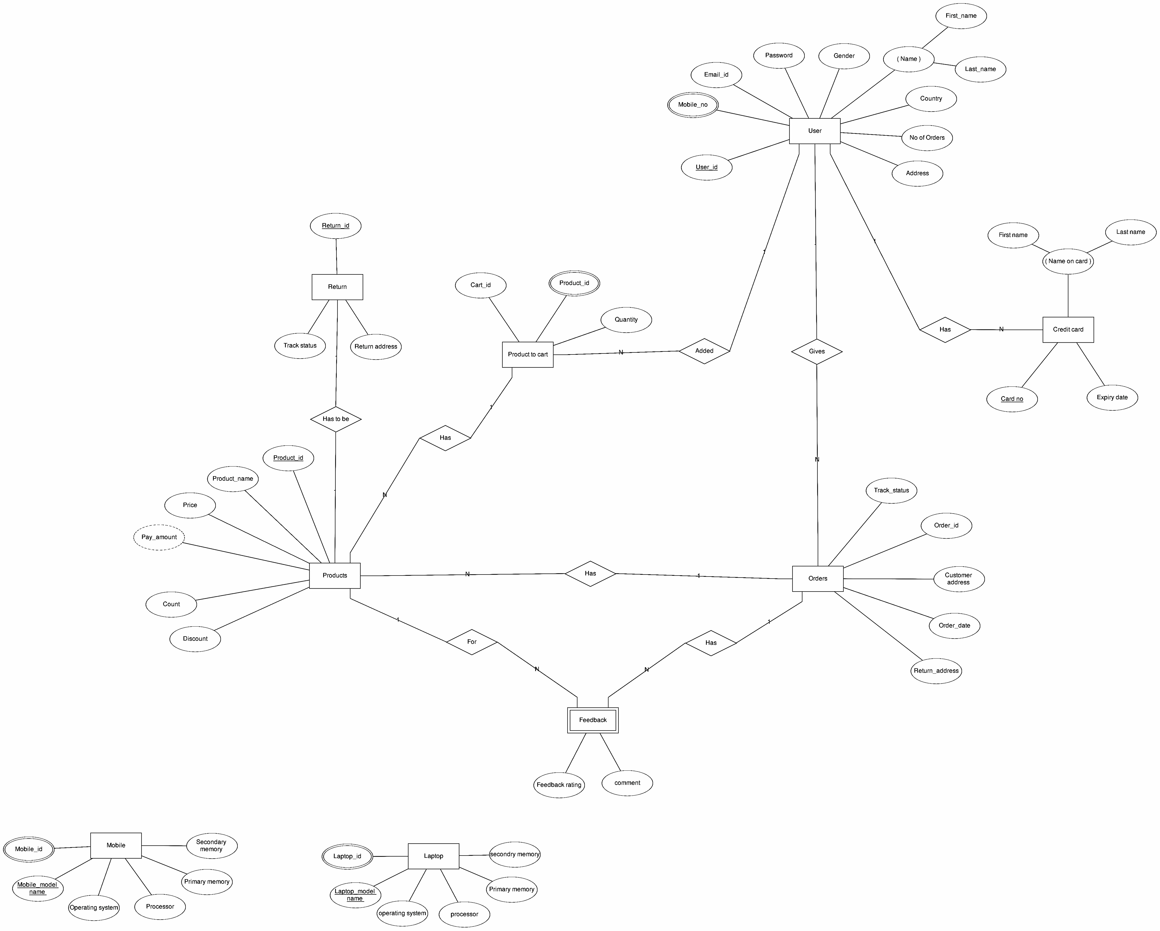

### **5. Other Non-functional Requirements**

#### Performance Requirements

The desktop application is supposed to give optimum performance if the requirments mentioned in Section 2.4 and Section 3 have been met. . **5**

#### 5.2 Safety Requirements

Changing or modifying user / products related data from the backend may cause malfunctioning of the desktop application in certain cases. Any such change/modification must be done only under developers guidence or advice.

#### 5.3 Security Requirements

The product could only be used by user (both admin and customer) only after agreeing the terms and conditions of use which must be accepted during the installation of desktop application.

**5.4 Software Quality Attributes**

**5.4.1 Usability**

1. The software must have a simple and user-friendly Interface.
2. The navigation to various pages should make it more convenient to the users so as to save time and confusion.

**5.4.2 Maintainability**

Application maintenance should be done regularly to facilitate smooth functioning of the system established.

**5.4.3 Portability**

Application is compatible with Linux (Ubuntu) as well as Windows (using NetBeans and MySQL).

## 5.5 Business Rules

### In case if the theres any need of addition or deletion an admin’s account, it could only be done by joint conscent of other admins. The conscent is to be submited to the developers team. The team will implement the changes asked, within twenty four working hours.

### **6. Other Requirements**

Only the licensed versions of the desktop application are considered legal. Any malpractices such as using cracked versions, distribution or copying of this application may attract heavy penalty

### 

**6**

### Appendix A:

### Sr.no

### Appendix B: Analysis Models

**TERM**

**DESCRIPTION**

1.

GUI

Graphical User Interface

2.

RAM

Random Access Memory

**Use-Case Diagram for Student:**

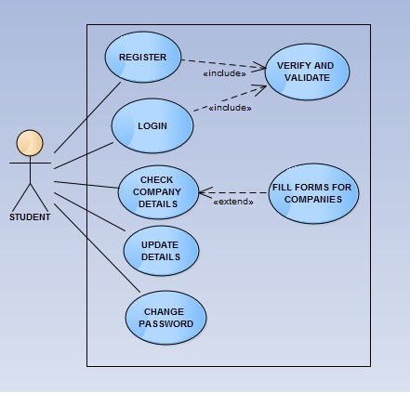

**7**

**Entity-Relationship Diagram:**

**8**